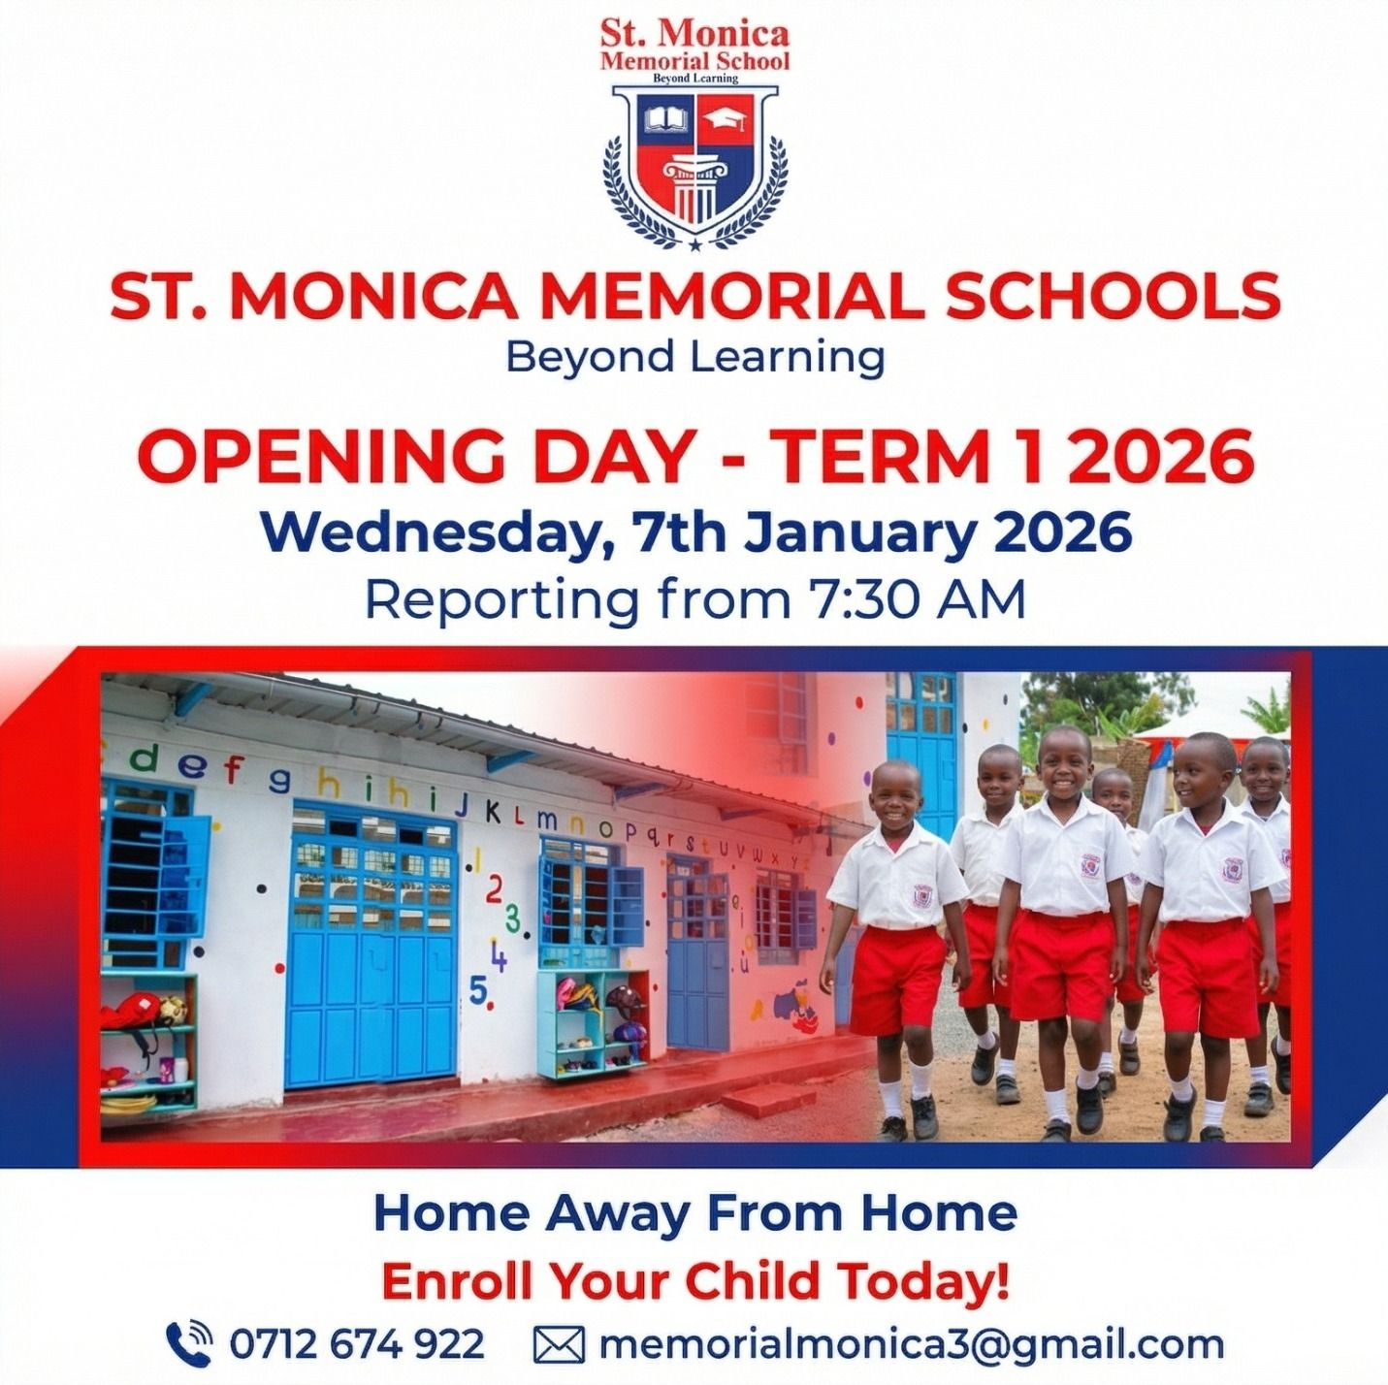
Homework & Assignment Policy

A primary school homework policy in ST MONICA SCHOOL establishes clear guidelines focusing on daily reading, skill reinforcement, and time limits by grade level.

Key elements include defining the purpose, setting weekly time expectations, and outlining roles for teachers, parents, and students.

Purpose and scope

- Reinforce learning: Connect home tasks directly to current classroom lessons.
- Build Habits: Foster independent time management, organization, and responsibility.
- Engage families: Keep parents informed about ongoing classroom topics and child progress.

Time Expectations by Grade Level

- Pre-primary / Lower Primary (PP1–G2 / Ages 4–7): Maximum of 60 minutes per week, consisting mostly of daily reading and simple spelling practice.
- Middle Primary (Grade 3–4 / Ages 8–9): Around 1 hour per week, adding basic Maths practice and short writing tasks.
- Upper Primary (Grade 5–6 / Ages 10–12): 1 to 2 hours per week, incorporating light project work, research, and topic revisions.

Responsibilities

- Teachers: Assign purposeful tasks, ensure instructions are clear, and provide timely feedback.
- Parents: Provide a quiet workspace, encourage routine, and communicate with staff if tasks cause undue stress.
- Students: Record assignments accurately, complete work on time, and ask for help early if confused.

